Monthly Targets Load Process

At the end of the month the contact centre manager will send a spreadsheet with the agents’ targets for the following month. Save a copy of this file in GIT\SQLDev\Documentation\Targets\Targets spreadsheets\YYYY where YYYY is the current year.

Check the spreadsheet thoroughly to make sure that:

* **Each name / Dept / Branch combination appears only once**.A CV sale agent may have separate targets for Dept (EB/ NB) and for different branches (0 or 3). Beyond this there should be no duplication of names. If there are duplicates it will double the income total on the scorecard and Daily COD Report due to joins!
* **Team name is populated for every row**
* **Team names are consistent including spaces**, e.g. “Van - EB” and “Van - NB” instead of “Van -EB”, “Van-NB” etc, otherwise they will not be correctly matched to a team ID.
* **The correct month and year is in the HierarchyMonthID column**, especially that the year has been changed in January!
* **The MonthlyTarget column is formatted as Number** otherwise it will not paste into the table in the next step. Reduce the number of decimal places to two using an =ROUND(<cell>,2) formula.
* **Dept column is populated with ‘Existing Business’ or ‘New Business’ for every row.** The changes made in Qlikview to allow agents to have separate NB and EB targets mean this must now be populated correctly for every agent. The load script expects the values to be exactly as shown. If any values are missing then it should be possible to determine from the team value. If not, reply to the person who sent the targets to check.

If any of the above is incorrect:

1. Respond to the email, asking for corrections to be made next month, and CC Jon Miles.
2. Make corrections before loading into the database in the next step.

Delete any rows where TGSL name is “Spare”.

## Load the spreadsheet into the staging table

Open Microsoft SQL Server Management Studio and connect to MHGSQL01\TGSL.

Truncate the table dbo.AgentMapWithTargets in the StagingTables database to remove any previously loaded data:

TRUNCATE TABLE [dbo].[AgentMapWithTargets]

Locate the table dbo.AgentMapWithTargets in the StagingTables database. Right-click and select Edit Top 200 Rows.

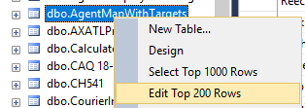

Copy the correct columns for the new month’s rows from the spreadsheet (there is an additional Unit Target field in the database table but this has never been added to the spreadsheet despite us asking). Right-click at the left of the blank row in the empty table and paste the rows in:

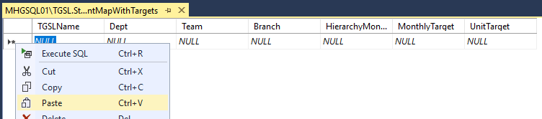

Note that any text values in the Branch column will be dropped as the column is an integer. This is OK; we are only interested in branch 0 and 3.

If the target amounts do not paste correctly, format the column as Number in Excel and try again.

## Insert targets and teams into CRM database

In Microsoft SQL Server Management Studio, open the script file MGL-QVW-SVR01\e$\Admin\Documentation\Month end\Monthly teams and targets load script.sql

Do not execute the script in its entirety, but step through it, following the prompts.